Reviewer #1: The manuscript addresses the question of whether there is a temporal discounting computation carried out in the prefrontal cortex, and if this is universal or strategy specific. Two monkeys were trained on a two-step temporal discounting task, and neural recordings were conducted in the dlPFC with seven recordings from one monkey and sixteen from the other. The monkeys showed different strategies for temporal discounting, with only Monkey S adjusting the temporally discounted value based on the go signal. The encoding of reward and delay in dlFPC appeared to be integrated in Monkey S, but encoded independently in the Monkey T, reflecting their different temporal discounting strategies. Both monkeys perform temporal discounting; however, the two-step design of the task doesn't impose a necessity for the animals to update primary temporal discounting computations, demonstrated by the monkeys' use of different strategies. The results are interesting and most of my questions are centered on trying to clarify similarities and differences across the animals.
Main comments
1. Monkey T didn't seem to integrate the delay presented by the go signal with the evaluation of reward and delay of the original offer, and encoded reward and delay independently. Inverse coding of reward and delay following cue onset, during the 'evaluation period,' provides evidence for temporal discounting computations in both monkeys, however does this inverse coding persist following the go signal?
Monkey S adjusted the temporal discounted value based on the go signal, but Monkey T did not, therefore there could be a presumed difference in this inverse coding following presentation of the go signal.
Siyu Analysis: inverse coding at GO cue
Thank you for this observation. We have extended the same analysis after the go signal. Precisely…
We can show the plots and justify what we have if we have noise or whatever we can argue here only!
2. Recording sites on Monkey S and Monkey T were quite different. Do the differences in the linearity of coding between the monkeys (10% in Monkey S and 33% in Monkey T) reflect a true difference in linear processing, or is it due to the neurons being sampled from different sites? Is this difference in coding demonstrated in the neurons that are sampled from overlapping areas recorded across the two monkeys?
We thank the reviewer for this important point. We agree that differences in recording sites could potentially contribute to differences between monkeys. The exact anatomical correspondence across animals cannot be established in our dataset. But if we examined the distribution of linearly coding neurons across the two recording arrays in Monkey S, we found that in the array that largely overlapped the recording site in Monkey T, we identified only 3 linearly coding neurons among 44 recorded neurons (~7%), already substantially lower than the proportion observed in Monkey T.
T – 33%
SA – 7%
SP – 13%
However, these observations are based on only six linearly coding neurons in total in Monkey S and therefore should be interpreted with caution. We have revised the manuscript accordingly.
Please see changes:
Are there any other differences in distributions for the other analyses that might correlate with anatomical location?
We can check for other analyses? I think a way to answer is maybe using the comparison between Arrays in Monkey S and as for the linear coding showing that if we see differences we see also in the array that overlap the most with array of Monkey T.
Run 1- 2 analyses separating SA, SP
3. How much more training did Monkey S have compared to Monkey T? Perhaps this task would not evoke different strategies for temporal discounting if training was comparable between monkeys. Did early sessions with Monkey S reflect the strategy that Monkey T used, suggesting that increased experienced in the task resulted in shifting strategies?
Incidentally. Monkey S learned in a week.
We appreciate this important point. Unfortunately, prior to neural data collection, we cannot determine if Monkey S received substantially more training than Monkey T or if the same behavioral strategies would have emerged with more or less training.
For instance, We cannot determine if the strategy adopted by Monkey S would have emerged in Monkey T with additional training or if Monkey S would have exhibited similar behavior to that of Monkey T in the early stages of training.
For this reason, we cannot disentangle the effects of training history from interindividual differences. However, in the dataset we analysed here, the two monkeys exhibited different behavioral patterns in the task, and these differences were reflected in their neural activity. Determining how behavioral strategies and their neural correlates evolve with experience is an important question that our dataset cannot address, but that would be valuable to investigate in future studies. We have clarified this limitation in the discussion. Please see:
4. It seems that the majority of the neural results presented are different between the two animals, which is understandable given the goal of the manuscript and the apparent behavioral differences between the two animals. However, it would be nice to have a positive control. Is there some aspect of the animal behavior and corresponding neural coding that is the same? Responses on opt in vs opt out? Errors? I am curious about those responses as well even if they aren't the same.
1. Neurons encode delay and magnitude
2. Delay vs magnitude is inversely encoded
3. minimal choice activity in both monkeys
4. Opt-in Opt-out (Siyu can check)
We thank the reviewer for this helpful suggestion. Consistently for both animals, we found no choice representation in this task, as presented in Figure S1 and S2 . When we compared the response in the cue period based on whether the trials are accepted or refused, we found no evidence that the upcoming choice outcome (accept vs. reject) modulated neural activity during the offer period in either animal (see figure below).
For each cell, we took all conditions in which there were at least five accepted and five refused trials. One-way ANOVAs for each condition confirmed that spike counts during the offer period did not differ significantly between accepted and rejected offers (N = 770 conditions; 35/598 for monkey T and 8/172 for monkey S; 1-way ANOVAs, p < 0.05).
These results suggest that dlPFC neurons do not represent the animal’s commitment to a choice.
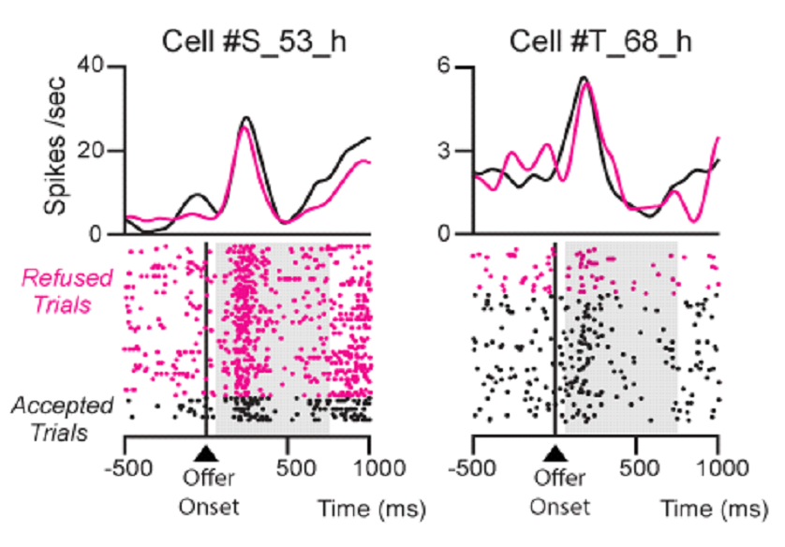
Other comments
1. The cues in the task have visual similarities that co-vary with the delay and drops of juice. There are visually responsive neurons in dlPFC. Is it possible to at least partially isolate responses due the cue by examining when the same cue is in different "roles" (e.g., behind a purple vs yellow cue or when it's accepted vs rejected?)
- Acknowledge the conceptual confound of visual vs delay/drop
- Order of delay/drop suggests it’s more likely not a visual effect
We thank the reviewer for this thoughtful suggestion. We considered the proposed comparison between accepted and rejected trials for the same cue. However, if we do this analysis in the offer period, it primarily tests whether cue-evoked activity is modulated by the animal's subsequent behavioral response. As we show from the response for the comment above, we did not find differences in the neural response for the same cue for accepted and rejected trial during the offer period. We think that this result shows that there is no anticipation of the animal’s subsequent choice. If we were to see instead a difference, we might say the opposite.
Similar scenario if we also include yellow vs purple go signals. Even in this case the go signal are not only visual objects per se but they mean a decision.
Moreover, because the cue set was constructed by recombining a limited set of simple geometric features encoding reward and delay, visual properties are inherently coupled to task variables. Therefore, a complete dissociation between visual and task-related encoding is not possible in the present design.
Is this feasible? Or Does it make any sense?
However, to address the possibility that neural activity was driven primarily by the visual identity of the cues, we examined pairs of offers that had similar discounted values according to the behavioral discounting model, despite being represented by different visual cue combinations vs pairs of offers that had different discount values and were represented by different visual cue combinations.
For Monkey S we compared pairs D and I and F and A versus pairs G and C and H and B. For monkey T we compared pairs E and I and A and F versus pairs G and C and H and B.

2. The explanation (in words) of Model 2 was even more simple and straightforward in the methods, whereas it was a little hard to follow in the results. Would recommend clarifying/rephrasing in the results.
I can check!
3. The hand/bar icon on Figure 1 (and the difference between open and closed) is a bit hard to see and it made it a little confusing to initially understand the task.
Ok, we can fix it!
Reviewer #2: This review identifies several areas where the manuscript would benefit from clearer conceptual and analytical presentation. The main concerns are that the computational models are not specified sufficiently to evaluate the proposed decision processes, key neural analysis terms and methods require clearer definition, and the link between go-signal-related neural activity, recalculated value, and behavioral strategy remains underdeveloped. Overall, the manuscript addresses an interesting question, but stronger model clarity, methodological transparency, and tighter integration between behavioral and neural findings would substantially improve the interpretation of the results.
1. Clarification of the computational models
To model the differential effects of the purple and yellow go signals, the authors compare three models, Models 1-3, that appear to correspond to different hypothesized decision processes. However, in the current version of the manuscript, the models are difficult to evaluate because their details are not described with sufficient clarity. In particular, the same notation appears to be used for different model components, notation is not always consistent within a given model, and some of the equations may contain errors. These issues make it difficult to determine precisely what decision processes the models are intended to represent.
First, the baseline model, which does not incorporate a go-signal-dependent decision process, does not appear to be a reinforcement-learning model as currently described. Rather, it seems to be identical to Model 1, with the parameters V, θ, and β replaced by DV, θ, and σ, respectively. In addition, in Model 1, if the discounted value is being compared against a decision threshold, the exponent term would seem more naturally expressed as DV-θ, rather than -V-θ.
Second, the authors appear to assume that the yellow and purple go signals add or subtract a fixed bias from the discounted value, and that this bias-modulated discounted value is then compared with a decision threshold to determine whether the offer is accepted or rejected. However, the manuscript formulates this process using (-U-θ±β)/σ as the exponent of the softmax function.
This expression is difficult to interpret because U is not defined, and β is also used as the inverse-temperature parameter in the baseline model. To improve clarity, the authors may wish to define all variables explicitly and use distinct notation for different quantities.
If the intended model is a threshold-based comparison of a bias-modulated discounted value, the exponent might be more clearly written as:
(DV±Bias-θ)/σ
where DV is the discounted value, Bias is the go-signal-dependent bias, θ is the decision threshold, and σ controls choice stochasticity.
Third, Model 3 appears to incorporate a hypothesized process in which the discounted value of the offer is recalculated in anticipation of an additional delay, ΔT. The authors then define a quantity referred to as "total value," which appears to be the sum of the recalculated discounted value of the current offer and the average discounted value of future offers in the task, presumably reflecting the expected value associated with rejecting the current offer.
This "total value" formulation would benefit from further clarification.
In response to a go signal, the monkeys are presumably deciding whether to accept or reject the current offer. Therefore, it seems that the quantity entering the softmax function should reflect the relative value of accepting versus rejecting the offer, rather than the sum of these values. Specifically, the exponent of the softmax function would seem to depend on:
V_"accept" -V_"reject"
Under this interpretation, for the yellow go signal, the value of accepting would be the recalculated discounted value of the offer incorporating the additional delay:
V_"accept,yellow" =R/(1+k(D+ΔT))
For the purple go signal, the value of accepting would be the original discounted value of the offer:
V_"accept,purple" =DV
The value of rejecting would also depend on the go-signal condition. For the yellow go signal, if the monkey can reject the offer immediately, then:
V_"reject,yellow" =θ
For the purple go signal, if rejection is associated with an additional delay, then the rejection value should be discounted as:
V_"reject,purple" =θ/(1+kΔT)
Thus, if this is the intended decision process, the softmax exponent should be based on the difference between the value of accepting and the value of rejecting, with each term defined according to the specific go-signal condition.
More generally, the manuscript would be strengthened by explicitly describing the differential predictions generated by the three models and by reporting the estimated parameters of the best-fitting model.
Show model-fit parameters
In the absence of these details, it is difficult to assess how the models were fit to the data and how the resulting model comparison supports the authors' interpretation, particularly given the apparent inconsistencies in the current model formulations.
2. Clarification of population coding dimensions
In reporting neural modulation by reward and delay, the authors repeatedly refer to "population coding dimensions" based on beta coefficients from an ANOVA analysis. This approach would benefit from further clarification. In particular, beta coefficients are typically associated with regression models rather than ANOVA, so it would be helpful for the authors to explain how these beta coefficients were obtained from the ANOVA analysis and what specific quantities they represent.
SIYU
In addition, the definition of "population coding dimensions" should be clarified. For example, are these dimensions intended to represent coordinates or axes defining a subspace of high-dimensional neural activity? Providing a more explicit description of how these dimensions were constructed and how they should be interpreted would make the neural population analyses and the corresponding figures much easier to evaluate.
SIYU
3. Clarification of the analysis relating go-signal modulation to recalculated discounted value
To test whether dlPFC neurons represent a recalculated discounted value at the time of the go signal, the authors examine whether neural activity is modulated by the yellow versus purple go signal in a manner similar to its modulation by reward and/or delay, which are integrated into discounted value. This is an interesting analysis, but several aspects would benefit from further clarification.
First, in the figure corresponding to this analysis, the authors correlate "inferred time" with reward and delay modulation.
However, the manuscript does not clearly describe what "inferred time" measures or how it was estimated. Providing a more explicit definition of this variable would help readers interpret the analysis.
SIYU.
Second, it is unclear how neural modulation by the go signal was measured independently of modulation by offer value. The authors present neural activity during the cue period, but not during the period when the go signal was presented, when the potential recalculation of discounted value would presumably occur.
In addition, Figures S1 and S2 appear to show that dlPFC neurons exhibit little modulation by the go signal itself. Given this, it is difficult to understand how go-signal-related neural modulation was analyzed in relation to the proposed recalculated discounted value.
If the authors' interpretation is that dlPFC neurons encode an adjustment of discounted value after the go signal, it would be helpful to show this more directly. For example, the analysis would be more compelling if it demonstrated how neural activity changes from the pre-go-signal to post-go-signal period in a way that reflects the proposed value adjustment.
Contrast activity between [-200 0 ] vs [0 200] around GO cue.
4. Relating individual differences in neural modulation to behavioral strategy
The authors report that the two monkeys may have used different behavioral strategies and also describe individual differences in several aspects of neural modulation. It would be helpful if the authors could further discuss how these individual differences in neural activity might relate to the observed differences in decision strategy. For example, do the monkey-specific patterns of neural modulation provide a possible mechanistic explanation for differences in how each animal evaluated or responded to the offers? Clarifying this relationship would help strengthen the link between the neural findings and the behavioral interpretation.
Explain the link between Model 3 and neural result Fig 6 for Monkey S and not monkey T.

